**2025**

**Okello Raymond, 0778412136**

Data Analyst

**2/7/2025**

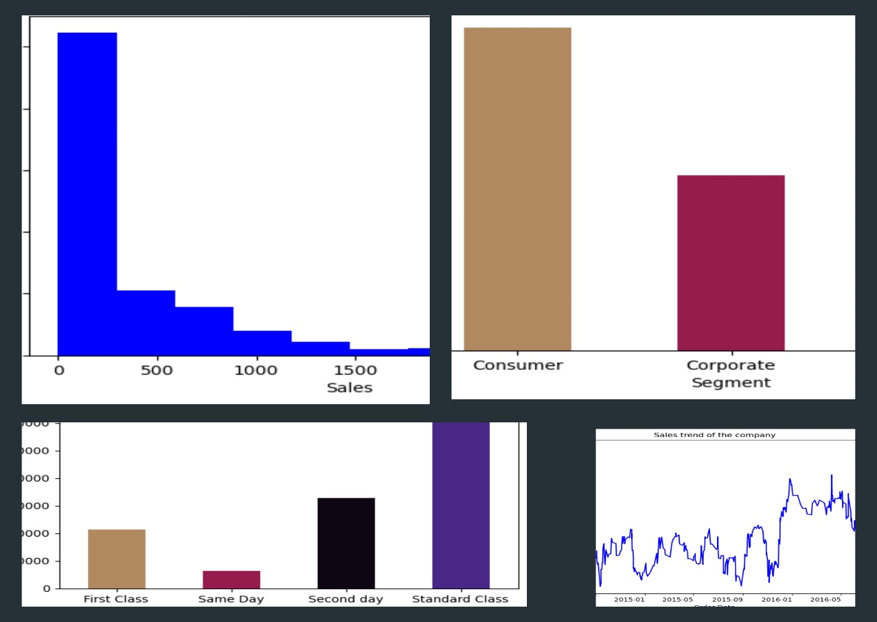

SALES DATA CLEANING

***For Exploratory Analysis***

**SALES DATA CLEANING**

# INTRODUCTION

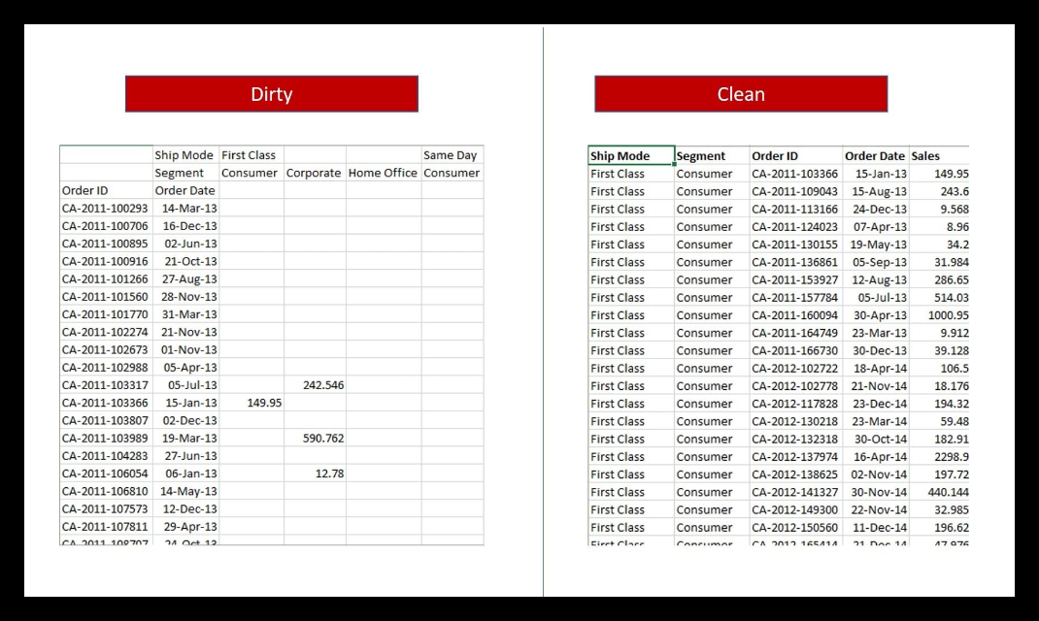

Data quality plays a crucial role in making accurate, data-driven decisions. Raw datasets often contain inconsistencies such as missing values, incorrect data types, and redundant information, which can lead to misleading insights.

This report outlines the process of cleaning and refining a dataset that will be later used to make simple exploratory data analysis

To ensure accuracy and efficiency, the dataset was transformed into a structured format, improving usability for analysis and visualization. This report details the exploration, cleaning steps, challenges faced, and the final cleaned dataset, providing insights into best practices for data preparation.

# DATA EXPLORATION

Before cleaning the dataset, an initial exploration was conducted to understand its structure, data types, missing values, and potential inconsistencies as follows;

* 823 rows and 14 columns. These columns were not categorically correct for example, First Consumer as a column combines First Class Consumers which needs to be split as (Ship Mode and Segment) columns
* The column Segment lists the dates ordered, this needed to be renamed to its appropriate format and data values
* With this unnecessary column headers, sseveral columns with missing values were found

# DATA CLEANING STEPS

To improve the dataset’s quality and usability, several cleaning steps were performed. The goal was to remove inconsistencies, handle missing values, and restructure the data for better analysis.

* The dataset had two level headers, this was first reduced to one level in excel to combined headers such as First Consumer, Same Corporate, etc. This was only a step since there were still very many column headers which were unnecessary since the Segment, and Ship Mode columns could represent customer and shipping categorization.
* Creating a data frame for each of the four segments, this allowed me to create a column named “Ship Mode” and respective names were given according to the segment
* Null values were dropped from the respective data frame row meaning they don’t belong in that segment
* The Ship Mode were picked from the column names contained orders, this meant that for first class, the order belonged to consumer if there is a sale in that column.
* All this was done for all the four segments which was then combined to form one data frame
* Column names were reviewed for clarity. Order Date, Ship Mode, and Sales were retained without changes, ensuring consistency.
* By reducing the number of columns from **14 to 5**, memory usage dropped from **90.1 KB to 32.2 KB**, making the dataset more efficient

# CHALLENGES AND SOLUTIONS

## ****Handling Missing Values****

Several columns, including First Consumer, First Corporate, and First Home Office, had significant missing values. These columns were deemed redundant and removed during the cleaning process, eliminating the issue of missing data in those columns.

## ****Incorrect Data Types****

The Segment column was incorrectly stored as a datetime64[ns] type, leading to potential misinterpretation. The data type of Segment was corrected to **categorical (**object**)** to better reflect its intended use.

## ****Redundant Columns and Fragmented Data****

The dataset contained multiple columns representing the same segmentation categories (e.g., First Consumer, Same Corporate), making the data unnecessarily complex. Redundant columns were removed, and the Segment column was retained to categorize the data, simplifying the structure.

## ****Optimizing Memory Usage****

The original dataset used **90.1 KB** of memory due to numerous columns.  
**Solution:** By removing unnecessary columns and restructuring the data, the memory usage was reduced to **32.2 KB**, improving efficiency. These challenges were addressed through strategic cleaning steps, making the dataset more manageable and suitable for analysis

# EXPLORATORY DATA ANALYSIS

Exploratory Data Analysis (EDA) was performed on the cleaned dataset to uncover patterns, detect anomalies, and understand the relationships between variables. The key steps of the EDA process included summarizing statistics, visualizing distributions, and examining correlations.

For better insights, day and month columns from the order date column were added to see any daily or monthly sales trend.

## ****Summary Statistics****

The cleaned dataset now contains **822 rows and 5 columns**: Order ID, Order Date, Ship Mode, Segment, and Sales. Summary statistics for the Sales column revealed that the dataset was badly skewed to the left and sales above 3000 were filtered out. The result data set with 803 rows were used to describe the data set as follows:

* **Mean Sales**: 359
* **Median Sales: 148**
* **Standard Deviation**: 500

## ****Data Distribution and Visualizations****

* **Sales Distribution**:

The histogram illustrates the distribution of sales, showing a right-skewed pattern where most sales values are concentrated in the lower range. The highest frequency is observed in the smallest sales category, indicating that the majority of transactions involve low sales amounts.

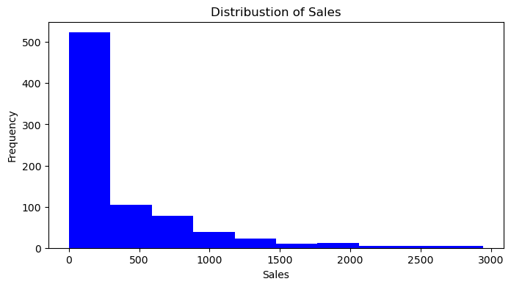

* **Segment-wise Sales**:

A bar chart was used to compare sales across different segments. This breakdown suggests that the Consumer segment is our primary driver of revenue. However, there may be an opportunity to grow the Corporate and Home Office segments through targeted marketing or customized offerings. Understanding the needs of these lower-performing segments could help diversify revenue sources and reduce reliance on a single segment. If necessary, further analysis can be done to identify trends, customer behavior, or product preferences within each segment.

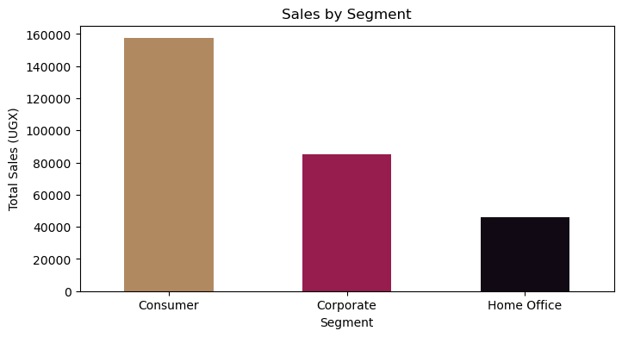

* **Ship Mode Sales**:

A bar chart was used to compare sales across different sales, highlighting that most customers prefer Standard Class shipping, likely due to cost-effectiveness or availability. The lower sales in Same Day shipping indicate that urgent deliveries are either less in demand or possibly too expensive for most customers. Further analysis could help determine whether pricing, availability, or customer preferences are driving these trends, which could inform decisions on optimizing shipping strategies and improving service offerings.

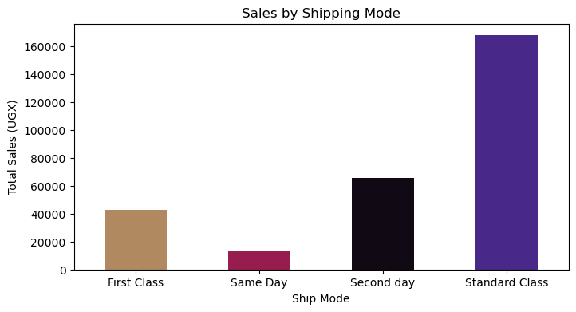

* **Monthly Sales Trend**:

The chart provides an overview of average monthly sales in UGX over a year, highlighting variations in performance across different months. February records the highest sales, while July and August see the lowest. Sales trends indicate a gradual increase toward the end of the year, with consistent performance from September to December. This summary reflects seasonal patterns and overall sales stability, offering insights for planning and decision-making.

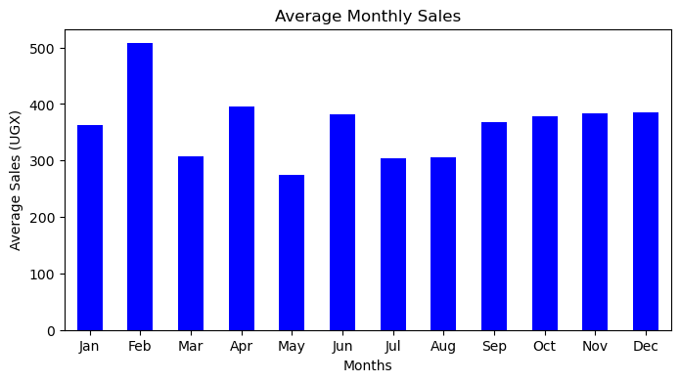

* **Weekly Sales Trend**

The chart shows the average daily sales in UGX over a week, highlighting variations in performance across the days. Friday records the highest sales, followed closely by Sunday and Monday, indicating strong consumer activity at the start and end of the week. Sales dip slightly on Tuesday and Wednesday but improve on Thursday. Saturday experiences the lowest sales, suggesting reduced activity on this day. Overall, the data reflects a weekly sales pattern with peaks on Fridays and weekends, offering insights into customer behavior that can inform targeted strategies.

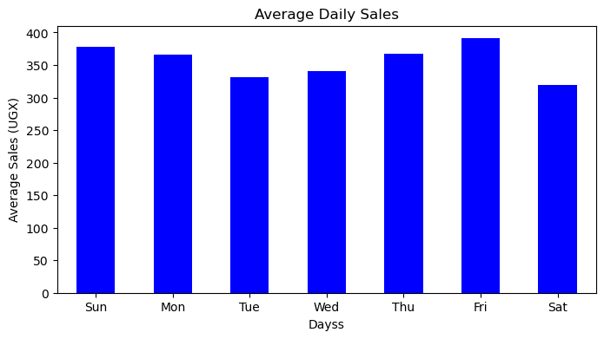

# CONCLUSION

Data cleaning played a huge part for this exploratory data analysis, without the structured dataset, it would be nearly impossible to come up with the charts above. While there is only little insights on timely trends on sales, segment and ship mode stands out as important features to dig deeper, this can help in making decisions that drive sales, minimizing cost and maximizing efforts on features that maters

Next steps:

* Find why sales are low for Home Office and Same day delivery
* Improve Sales for high end products that pay more

# TOOLS AND TECHNOLOGIES

* Excel
* Python Pandas
* Matplotlib

# REFERENCES

To get a hold of the datasets used in the above process, and insights that might have gone unnoticed, go through the datasets below

|  |  |
| --- | --- |
| Data Sources | |
| Unclean Data | [Click Here](https://docs.google.com/spreadsheets/d/1_nXdYH-ceuSyEy8W7eJnm-HtvqTTkRo9eS7nYxv7IYo/edit?gid=0#gid=0) |
| Clean Data | [Click Here](https://docs.google.com/spreadsheets/d/1CLEDIvfhSgrsDeQ89QskUEpvaYZu_w6XeB4MSyObrXk/edit?gid=1279021502#gid=1279021502) |
| Steps Taken | [Click Here](https://github.com/Rhahloth/data_clean/blob/main/code.ipynb) |